User Help Centre

Users  - Primary  - Kolavo registered users  - Secondary  - … | Phase 1
Intended Outcome
- Kolavo registered users can know about, access tutorial, or simply connect to Kolavo.
- …
Links
- …
- …
- …
- …
- …

Introduction
People accessing the Kolavo app may be confused about using it or curious about its company behind the app. Currently the marketing plan is still focusing on social media like LinkedIn for company profile, Youtube for tutorials, Instagram and Threads for connecting to the market. There is no plan to make any complicated or fancy page to show off Kolavo company. Hence, a small yet easy to access and distinct space is needed to centralize all these social media links named Help Centre. As it is believed that Kolavo page has been designed as intuitively and user friendly as possible, the Help Centre would be provided to registered users only through the User Profile page.

Product Requirement
No | User story | Scope | Acceptance Criteria
1 | As a registered user who struggles to use Kolavo, I want to have access to Kolavo tutorials, so I can fix my problems in using the app. | Link to Kolavo YouTube | - Listed as the first link to see Kolavo tutorial  - When clicked, the new tab / YouTube app is open.
2 | As a registered user who needs Kolavo support, I want to have access to Kolavo Threads, so I can easily ask for help from Kolavo support. | Link to Kolavo Threads | - Listed as the second link to reach Kolavo support.  - When clicked, the new tab / Threads app is open.
3 | As a registered user who wants to know Kolavo updates, I want to have access to Kolavo social media, so I can connect easily to Kolavo. | Link to Kolavo Instagram | - Listed as the third link to reach Kolavo to casually connect with Kolavo.  - When clicked, the new tab / Instagram app is open.
4 | As a registered user who is curious about Kolavo, I want to have access to a Kolavo profile, so I know more about Kolavo. | Link to Kolavo LinkedIn | - Listed as the fourth link to reach Kolavo to professionally connect with Kolavo.  - When clicked, the new tab / LinkedIn app is open.
5 | As a PM who loves users to stay, we want to hide the log out button here, so users are not encouraged to log out. | Logout button | - Listed as the last link with neutral to muted look  - When clicked, the user is logged out.
6 | As a registered user who looks for Kolavo further info, I want to see the help centre intuitively, so I can access it easily. | Kolavo Help Centre | - Show at the User Profile page changing the logout button  - When clicked, list is open

Design Requirement

Kolavo YouTube Link
Design Intent | To ease user accessing Kolavo tutorial in Youtube
Content / Copy | - Youtube logo + Access Kolavo Tutorial
Visual Requirement | - youtube icon
Interaction Behavior | - Clicking youtube link redirects to Kolavo App youtube
Acceptance Criteria

Kolavo Threads Link
Design Intent | To ease user reaching Kolavo support in Threads
Content / Copy | - Threads logo + Get Kolavo Support
Visual Requirement | -  threads logo
Interaction Behavior | - Clicking threads link redirects to Kolavo App threads
Acceptance Criteria

Kolavo Instagram Link
Design Intent | To ease user connecting with Kolavo in Instagram
Content / Copy | - Instagram logo + Connect with Kolavo
Visual Requirement | -  instagram logo
Interaction Behavior | - Clicking instagram link redirects to Kolavo App instagram
Acceptance Criteria

Kolavo LinkedIn Link
Design Intent | To ease user knowing about Kolavo company in LinkedIn
Content / Copy | - Linkedin icon + About Kolavo
Visual Requirement | -  linkedin icon
Interaction Behavior
Acceptance Criteria

Logout Button
Design Intent | To allow user logging out
Content / Copy | - Logout icon + Logout
Visual Requirement | - Neutral to muted color not Kolavo color  - To visitor:  - There is no logout button  - To logged in users:  - There is logout button
Interaction Behavior | - Clicking log out button, redirects user to homepage/community list page
Acceptance Criteria

Kolavo Help Centre
Design Intent | To ease user accessing Kolavo help centre
Content / Copy | - Binoculars icon
Visual Requirement | - 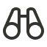 binoculars icon  - Use Kolavo’s brand color  - 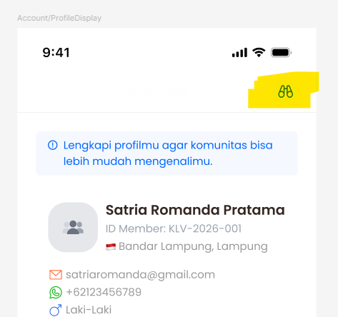  - In mobile mode:  - Homepage: align with Kolavo logo, at the right corner  - User Profile: at the right corner  - In PC mode:  - Floating at the right bottom corner  - Make it visible
Interaction Behavior
Acceptance Criteria

Engineering Requirement

Questions

